

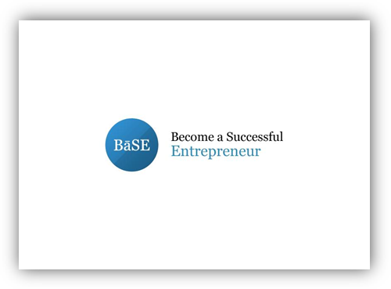 | DELIVERABLE:  02 – SCENARIO OF THE SIMULATION GAME  02-A1 - Development of the Scenario for the Simulation Game


Project Information
Grant Agreement Number: | 2014-2-CY02-KA205-000405
Project Acronym: | BaSE
Deliverable: | 02 – Scenario of the Simulation Game  02-A1 – Development of the Scenario for the Simulation Game
Activity Leading Organisation: | M.C. INSTITUTE OF PUBLIC RELATIONS  (CYPRUS) LTD/MCIPR
Participating organization: | University of Cyprus
Authors/Responsible Partner | Michael Constantinou / MCIPR  Kalliopi-Evangelia Stavroulia/MCIPR
Status: | Report

Table of Contents

Description of action

This report constitutes the second deliverable of the BaSE project for the duration of the period from 22 May 2015 to 30 June 2015. In particular, this second intellectual output identified as 02, had to do with one action:
02-A1. Preparation of the scenario of the simulation game that will be developed by the University of Cyprus.
The activity 02-A1 was implemented based on the specifications and premises that were defined in the proposal of the BaSE project.

Introduction

Introduction

  - Literature review
The use of simulation games in teaching and learning is not a new phenomenon but it has a considerable history as part of education. The last few decades, simulation games have become a new training paradigm and a popular tool providing realistic educational experiences. Simulation games are widely used in the military, in medical field for surgical training or in pilot training through pilot simulations (Kovalik & Kuo, 2012).
The simulation games literature does not reveal one globally accepted definition for the term, while the definition varies among the different professions and fields (Crookall, 2010). According to Sitzmann (2011), simulation games ‘refer to instruction delivered via personal computer that immerses trainees in a decision-making exercise in an artificial environment in order to learn the consequences of their decisions’ (pp. 490). Kikot et al. (2013), defines simulations as ‘a digital imitation of something real that has game characteristics: competition, rules’ (pp. 14). Simulation games offer learners the unique benefit of experiential learning where they ‘practice developing, implementing and controlling competitive strategies as well as making complex and functionally integrated decisions in a competitive environment that reflects real life’ (Zhang, 2015: 154).
Research results indicate the value of computer-based simulation games in education as an effective tool for the improvement of knowledge, competencies and skills. Simulations provide the users the opportunity to practice and develop their skills in a safe environment similar to that of the real world and deal with situations or dilemma that they are likely to occur in the future (Fowler & Pusch, 2010; Kovalik & Kuo, 2012). Equally important is that training via simulation games is less expensive than arranging training in a real environment that might be risky or unsafe (Kovalik & Kuo, 2012). Furthermore, within this low-risk environment players have room for error, as they can experiment, fail and start over again learning from their mistakes.
Simulation games promote active learning and it is learners’ responsibility to build their own knowledge during the process (Palmunen et al., 2013). Additionally, the use of games can increase motivation to learn and have a positive impact on students' learning performance (Randel et al., 1992; Kovalik & Kuo, 2012; Schwabe & Göth, 2005; Sitzmann, 2011; Terrell & Rendulic, 1996). Moreover, gaming can increase the interaction among the users while promote the development of skills in decision making and problem solving (Kovalik & Kuo, 2012; Schwabe & Göth, 2005). Additionally, simulation games offer players the possibility to try innovative strategies developing their creativity skills (Kovalik & Kuo, 2012). Furthermore, through constant playing of the game the player can develop critical learning skills (Kovalik & Kuo, 2012). Simulation games promote the development of the 21st Century skills that are considered to be critically important for a successful and sustainable future of new generations (Great Schools Partnership, 2014).
Another important aspect is that simulation games allow the users to transfer the knowledge learned in the traditional education to real-life situations connecting theory and practice. Thus, since simulation games represent situations similar to those of the reality, it is extremely important to create realistic experiences something that would be difficult to create in traditional training (Kovalik & Kuo, 2012).
Simulation games are widely used in the business field, although according to Kovalik and Kuo (2012) business simulation games are not frequently used as part of the curriculum mainly because it is difficult for educators to choose the suitable game, use it effectively and evaluate what the students have learned. Benita (1999), also argues that the importance of the use of business games lies in their ability to improve participants’ business skills and especially problem solving and decision making. Furthermore, business simulation experiences offer ‘unique learning benefits that allow business students to develop critical strategic management knowledge and skills needed in the marketplace’ (Zhang, 2015: 154).
Simulation games can be used for the training of employees in order to upgrade and improve their skills. Jana (2006) refers to the development of a simulation game for the training of the staff in customer service. According to the results those trained via the simulation game obtained assessment scores 5% to 8% higher than those trained with older techniques such as manuals. Research by Chang et al. (2003) relative to the implementation of business simulation games also identified the effectiveness of their use. The results of the study revealed that the use of the simulation game promoted the development of participants’ decision-making, problem solving and planning skills. Moreover, the game helped participants understand the concepts related to business.
Taking all the above into consideration, the ultimate objective of the BaSE project is the development of a business simulation game that aims to bridge the gap between the traditional training and real world work situations and enhance the development of the potential entrepreneurs’ skills. The simulation game will offer experience through practice in situations that reflect real-life situations in setting-up a business. The scenario will promote the development of decision-making, problem solving and planning skills while it will enhance participants’ understanding of the different concepts that are related to the establishment of a new enterprise.

  - The scenario of the simulation game
Wolfe and Gold (2007) argue that when developing an educational simulation it is essential that the game corresponds to the course content. Thus, for purposes of pedagogical effectiveness the design of the scenario was based on the following topics that will be covered during the training session that will take place both in Cyprus and in Greece:
- Business Plan
- Marketing
- Accounting
- Financing and Investment
- Controlling
- Enterprise planning and
- Economics
During the game the user will be responsible for the development of his/her new business – establishment of the legal person. The users will have to understand their objectives and choose the best course of action relative to the name of the enterprise, creation of logo or trademark, choice of type of business or registration of enterprise. The user will have to take the necessary actions in order to ensure the initial capital for the development of the company. The product or services provided by the enterprise must also be determined and the user will have to take into account several variables including the ways of promotion, the market plan, pricing policy etc. During the game players will have the ability to choose the appropriate facilities and equipment by taking into account various parameters including the location, the rent, the character or the fame of the area. Furthermore, the simulation game will allow the users to be trained in issues like staff recruitment, budget development, management strategies and crisis management.
The BaSE project aims to provide a representation of the main features of reality relative to the establishment of a new business that will allow the training of potential entrepreneurs in a low-risk environment. During the game the users will be required to make business decisions in order to achieve the goal of starting up a new business by taking into consideration how their decisions will affect their own choices.
Another significant aspect of the proposed simulation game relates to the feedback that the players will receive after the end of the simulation experience that will allow them to understand their decisions and their mistakes, reflect on them and improve their strategies.

The scenario

‘BāSE – Become a Successful Entrepreneur’
Edition 1.0

The simulation game

- Overview
BaSE is a first and third person interactive business simulation game that places the player in the body of a youth that is unemployed due to the economic crisis and decides to start up his/her own business.
In order to progress in the game the player must interact with the virtual characters and fulfill the tasks that will ensure the establishment of the company.
The game takes place in a city and it is a fully immersive environment allowing players’ interaction with the other people.
The player’s main task is to navigate the youth within the city, interact with other people to take instructions and visit all the necessary buildings for the establishment of the enterprise.
The game will reward the players creativity and choices relative to the steps and strategies followed for the establishment of the enterprise.

Game Concept
Due to the economic crisis and the lack of job opportunities in the labor market one youth decides to start up his/her own business. In order to start-up the business the youth must set up his/her business goals and expectations and reflect on how to meet those goals. Starting from scratch in order to create a new business, our youth must decide the product or service of the company, fulfill legal obligations, ensure funding, rent buildings, hire staff, choose logo and forwarding the business. An adventure journey begins and our youth will face several problems and challenges and will have to take the best course of action in order to achieve the establishment and survival of a successful enterprise. BaSE is a challenging business creation and management simulation game that will allow players to learn how to create and run a successful business.
Game objective
The games’ main goal is the establishment and maintenance of a successful enterprise. The smooth operation and survival of the enterprise for an amount of time will allow the player to win the game and become a successful entrepreneur.

Game environment
The game begins with our hero located in outer space at the center square of the city. There will be different paths that the players will be able to follow leading to different quests related to the creation of the new enterprise. The player will be able to move around and explore the city but at times the player will have to be contained into specific areas.
The background will contain buildings and singes that will show to the player the direction for every building that he/she must visit for the establishment of the company.
The world layout will consist of distinct areas, each one making up either a complete level or chapter (some areas may be split up into multiple levels depending on size and complexity). Each distinct area will correspond to different tasks relative the establishment of the new company.

Game walkthrough
The player will be able to visit the following spaces:
- Law firm
- Bank offices
- Real estate offices
- European Commission offices
- Sponsor’s offices
- Stores for business equipment
- Buildings for the accommodation of the business
- Graphic artists
- Family home

Market considerations and features
The game refers mostly to young and inexperienced people who wish to create their own business but have no skills, confidence and knowledge to do so. Through continuous practice young people will have the ability to experience real-life situations that are related to starting-up a new business and will face real-life problems that might encounter during the process of building a new business.
The simulation game addresses the lack of practical experience in higher education, lifelong learning and adult education organizations, proposing the connection of traditional education and practice in a low-risk virtual environment that allow room for error. The importance of the simulation lies in the ability to train young people who lack the skills and knowledge within a safe environment without the risk of negative consequences in case of inability to create and maintain a new business due to inexperience and possible incorrect choices.
The simulation in the future could be implemented as part of the curriculum within the university or life-long learning organizations for the acquisition of practical experience as it is difficult to arrange training for potential entrepreneurs in real settings. However, the different scenarios within the game and the various problems and challenges that the players will have to face will be the result of real-life situations as indicated by experienced entrepreneurs.

- Game Mechanics
Game engine
For the development of the BaSE simulation game the game engine that will be used is called Unity developed by Unity Technologies. Unity game engine is a system designed to develop games for various platforms like consoles, computers and handheld devices like smartphones.

Platform
This game is specifically developed for computer platform.

Camera system
BaSE can be played in two modes: first-person and third-person. The player will be able to switch between the two perspectives during the game. First-person perpective will allow the user to see through the eyes of the hero providing a realistic feel. Moreover, first-person perspective allow the immersion of players as they feel more connected to the game hero.
When switching to third-person, players will be able to see the actions from a distance. The player can see the avatar and its movements through the virtual world. Third-person perspective allows the user a better understanding of the environment and simplifies the navigation. The camera will be placed behind the character at a reasonable view of character and the current environment.

Game physics
The hero of the game will be moving and behave as real people. The hero will be able to jump either straight up and down or in a parabola going left or right. When an obstacle is in front of the character it will not be able to proceed further in that direction. Gravity should be present.

Game menu
The starting menu will have five buttons allowing the player to start a new game, save a game, load a game, see the options of the game and exit the game.
Once the player starts a new game the system will ask the player to choose for gender: male or female character. Afterwards, the system will ask the player to post his/her name. The name input will be used during the game as the name of the youth hero. Then, the instruction screen will appear providing the players with information about the game controls.

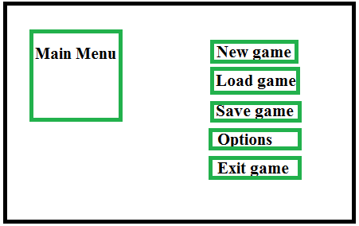
Figure 1: Main menu

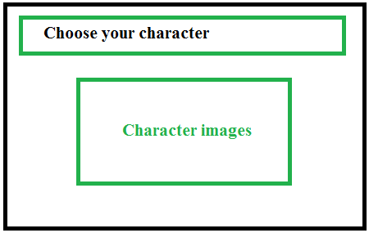
Figure 2: Character selection

If the player presses the options button the game controls menu will appear on the screen.

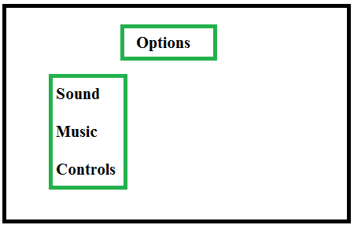
Figure 3: Options

If the player presses the exit button the end screen will appear.

General movement
The player will be able to move the hero forward, backward, left, and right in the virtual environment. The hero will be allowed to move slowly or quickly to a given direction. The hero will be able to jump will moving.

Score
The player will earn points for accomplishing the different tasks. The points will be negative or positive based on the choices of the players during the tasks. The use of specific strategies will give the player more points than the use of others. A total point system will be displayed during the game and a summary of the points won and lost according to the choices made will be displayed at the end the game. UI elements will be used to track the score that will appear in the corner of the screen, will be small but readable.
Game controls
Keyboard:
Move Forward: Arrow Key “⬆” or “W”
Move Right: Arrow Key “➔” or “D”
Move Left: Arrow Key “⬅” or “A”
Move Back: Arrow Key “⬇” or “S”
Jump: “Space”
Collect Items: “R”
Map: “M”
Inventory: “E”
Quest: “Q”
Interact: “I”
Talk: “T”
Change view: “Shift”
Go to menu: “ESC”

Levels
A rough overview of the game’s level progression is the following:
- Tutorial: A sort tutorial that takes place in the city in order for the player to be familiarized with the game environment, perspectives and controls.
- Level 1: Takes place at law firm office where the player must visit in order to establish the creation of the business.
- Level 2: Takes place in the Bank where the player has to visit in order to ensure funding.
- Level 3: Takes place in the sponsors’ offices where the player has to visit for funding.
- Level 4: Takes place in European Commission offices where the player can be informed about European funding opportunities.
- Level 5: Takes place in Real estate offices visited by the player in order to find and rent the space that will house the business.
- Level 6: Takes place at the graphic artists’ store where the player will go for the design of the logo or trademark. The player will be able to construct with the help of the designer the company logo that will appear during the game in the company’s building and documents.
- Level 7: Takes place at the family home as the player is looking for funding.

Dialogue
The hero will talk to different people during the game. Other characters will give advice, and other will assign the tasks. The GUI elements will disappear after a reasonable period of time, allowing enough time for the player to read the text. The dialog will appear at the middle of the bottom of the screen.
Some of the non-player characters will talk to our hero for a sentence or two. If the player wants to talk to a character he/she will have to push to appropriate action key when near the character.

In-game Information
During the game the player will receive information and hints in the form of wall illustrations, documents, screen messages that will help him decide the best course of action for the establishment of the new enterprise.

Inventory
The player will have a simple inventory in the form of a notebook where the different tasks will appear and the steps the hero followed in order to achieve the goals each time. The player will also be able to see the total score for each task.

Script Reference
Scripting will be used for the following:
- Movement
- Inventory
- Animation states
- Character status
- GUI
- AI
- UI
- Camera

Sound
A. Music
The game will have music playing during the entire course.
The music will be simple loops and should include:
- Opening section
- Menu Loop
- Standard Game Loop
B. Sound Effects
Sound effects will be included throughout the game.

Mind map

A mid map was design as the main body structure of the game containing the most important steps that a potential entrepreneur must follow in order to create a new company. The mind map was created based on the training materials that will be covered during the training courses.

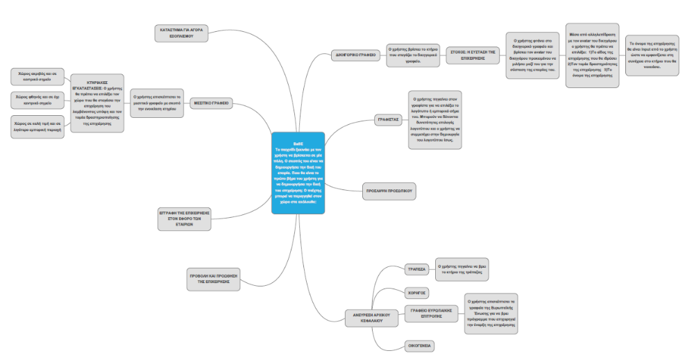

References

References

Benita M. Cox (1999). Achieving Intercultural Communication through Computerized Business Simulation/Games. Simulation & Gaming, 30 (1), 38-50.
Chang, J., Lee, M., Ng, K., and Moon, K. (2003). Business Simulation Games: The Hong Kong Experience. Simulation & Gaming, 34 (3), 367-376.
Crookall, D. (2010). Serious Games, Debriefing, and Simulation/Gaming as a Discipline. Simulation and Gaming, 41 (6), 898-920.
Fowler, S.M. and Pusch, M.D. (2010). Intercultural Simulation Games: A Review (of the United States and Beyond). Simulation & Gaming, 41 (1), 94-115.
Great Schools Partnership (2014). 21st Century skills. Available at: http://edglossary.org/21st-century-skills/ last access June 10, 2015.
Jana R. (2006). On-the-job video gaming. Business Week, 3977, 43.
Kikot, T., Costa, C., Magalhães, R., and Fernandes, S. (2013). Simulation Games as Tools for Integrative Dynamic Learning: The Case of the Management Course at the University of Algarve. Procedia Technology, 9, 11-21.
Kovalik, C. L. and Kuo, C.L. (2012). Innovation Diffusion: Learner benefits and instructor insights with the DIFFUSION SIMULATION GAME. Simulation & Gaming, 43 (6), 803-824.
Palmunen, L., Pelto, E., Paalumäki, A. and Lainema, T. (2013). Formation of Novice Business Students’ Mental Models Through Simulation Gaming. Simulation & Gaming, 44 (6), 846-868.
Randel, J. M., Morris, B. A., Wetzel, C. D., & Whitehill, B. V. (1992). The effectiveness of games for educational purposes: A review of recent research. Simulation and Gaming, 23(3), 261–276.
Schwabe, G., & Göth, C. (2005). Mobile learning with a mobile game: Design and motivational effects. Journal of Computer Assisted Learning, 21(3), 204–216.
Sitzmann, T. (2011). A meta-analytic examination of the instructional effectiveness of computer-based simulation games. Personnel Psychology, 64 (2), 489–528.
Terrell, S., & Rendulic, P. (1996). Using computer-managed instructional sSoftware to increase motivation and achievement in elementary school children. Journal of Research on Computing in Education, 26(3), 403–414.
Wolfe, J., and Gold, S. (2007). A study of business game stock price algorithms. Simulation & Gaming, 38 (2), 153-167.
Zhang, M.J. (2015). Using login data to monitor student involvement in a business simulation game. The International Journal of Management Education, 13 (2), 154-162.

